METLIFE
APPLICATION
RUNBOOK
GUIDE

Table of Contents
1.0 General 8
1.1 Document Change History 8
2.0 Application Overview and Configuration 9
2.1 Application Overview and Business Objectives 9
2.2 High Level Architecture Diagram 9
2.3 Azure Conceptual Diagram 10
3.0 Software Configuration 11
3.1 General Software Components 11
3.2 Software Configuration – Workstation 12
3.2.1 Overview 12
4.0 Startup/Shutdown <Review and Update> 13
4.1 Overview 13
4.2 Webserver Startup / Shutdown Procedures 13
4.3 Application clusters Startup / Shutdown Procedures 13
4.4 Database Server Startup / Shutdown Procedures 13
4.5 Mainframe Startup / Shutdown Procedures 13
4.6 Application Startup / Shutdown Procedures 13
5.0 Backups 13
5.1 Overview 13
5.2 Web Server Backup 13
5.3 Application Backup 13
5.4 Database Backup 14
5.5 Mainframe System Backup 14
6.0 Restoring 14
6.1 Overview 14
6.2 Webserver Restore 14
6.3 Application Restore 14
6.4 Database Restore 14
6.5 Mainframe Restore 14
7.0 Application RACI 15
8.0 RACI for cloud 15
9.0 Azure DevOps 16
10.0 Job Scheduling/Monitoring 16
10.1 Overview 16
11.0 Disaster Recovery 17
12.0 Incident Management 18
13.0 Problem Management 19
14.0 Service Management 19
15.0 Contact Lists 20
16.0 ANY SPECIAL INSTRUCTIONS FOR THIS APPLICATION 20
17.0 TROUBLE SHOOTING 20
18.0 HELPDESK INFORMATION (CS PROJECT OFFICE) 20
19.0 SECURITY 22
19.1 NETWORK USER ACCOUNT CREATION 22
19.2 NETWORK USER PASSWORD MAINTENANCE/RESET 22
20.0 Appendix A- Glossary of Terms 22

Runbook Rules
- You have to follow the format, do not change the section numbers (This will standardize all applications and make it searchable) You can create sub sections within the original sections if needed.
- Runbook must be kept current. If the runbook is updated, then the updated runbook must be placed as an attachment in the Metddb.
- Any changes to the architecture has to be coordinated with the Deployment Services individual assigned to your application.
- Once the runbook is completed, there will be minimal Metddb entries that will have to be filled in.
- No custom monitoring will be implemented until the runbook is completed and the Metddb is filled out.
- Lead-time, the runbook must be completed three weeks prior to when the application will go into production. This will allow time for the implementation of Tivoli monitors.
Who is the AM individual responsible for keeping the runbook current (Primary) Mike Zeng. (Secondary)Catherine Bhama If the AM individuals move on to another application and are no longer associated with this application, a new individual must be assigned to this task.

GRID - Global Repository for Investments Data

For
MetLife Investments Management

By
Jatin Chauhan, Francesco Puntillo
Investments

General

Document Change History
The following table documents changes made to the Operations Procedures Guide and should be filled in each time a change within the runbook occurs.
PLEASE UPDATE INFORMATION FOR YOUR APPLICATION.
Section Changed | Change Description | Changed by | Date of Change | Comments
ALL | Initial Creation | Catherine Bhama | 8/27/19
ALL | Reviewed By | Jatin Chauhan, Francesco Puntillo | 8/28/19
6.0,11.0,12.0,13.0 | Updated Azure RCAI, Incident, Problem and Service management work flow | Catherine Bhama | 8/29/19
2.4 | Updated Azure Architecture and infrastructure diagram | Catherine Bhama | 8/30/19
9.0,10.0 | Updated Backup and Restore process. | Catherine Bhama | 9/26/19

Application Overview and Configuration

Application Overview and Business Objectives
The Global Repository for Investment Data (The GRID) will serve as an online historical repository for all Investment data published/consumed by technology systems and/or data received by the Investments organization.

High Level Architecture Diagram
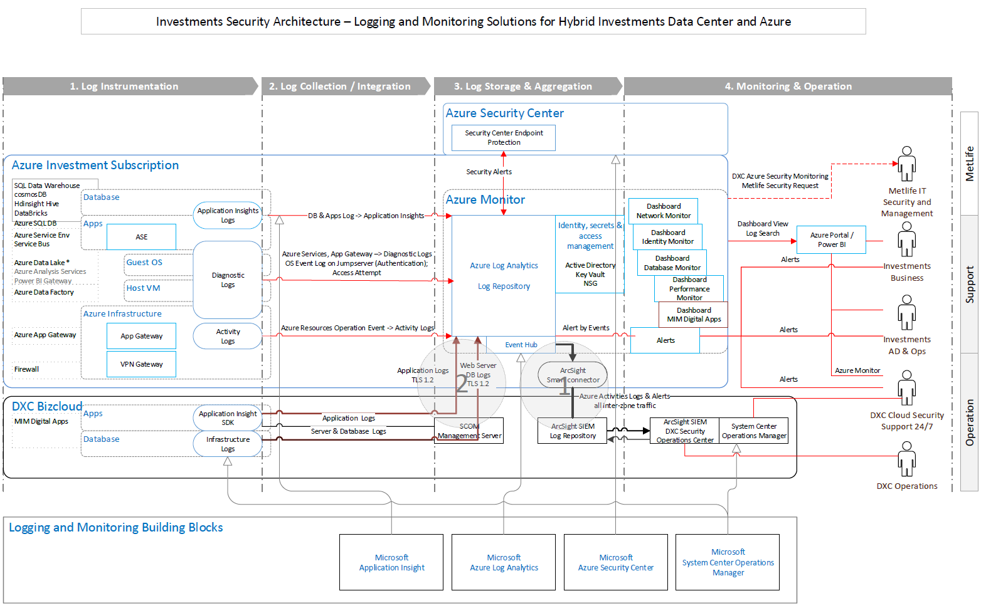

Azure Conceptual Diagram
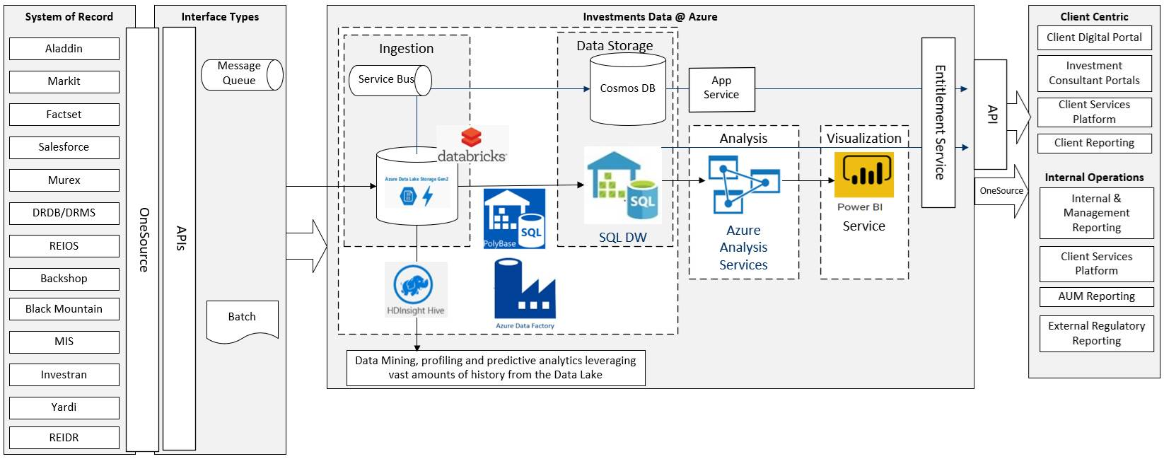
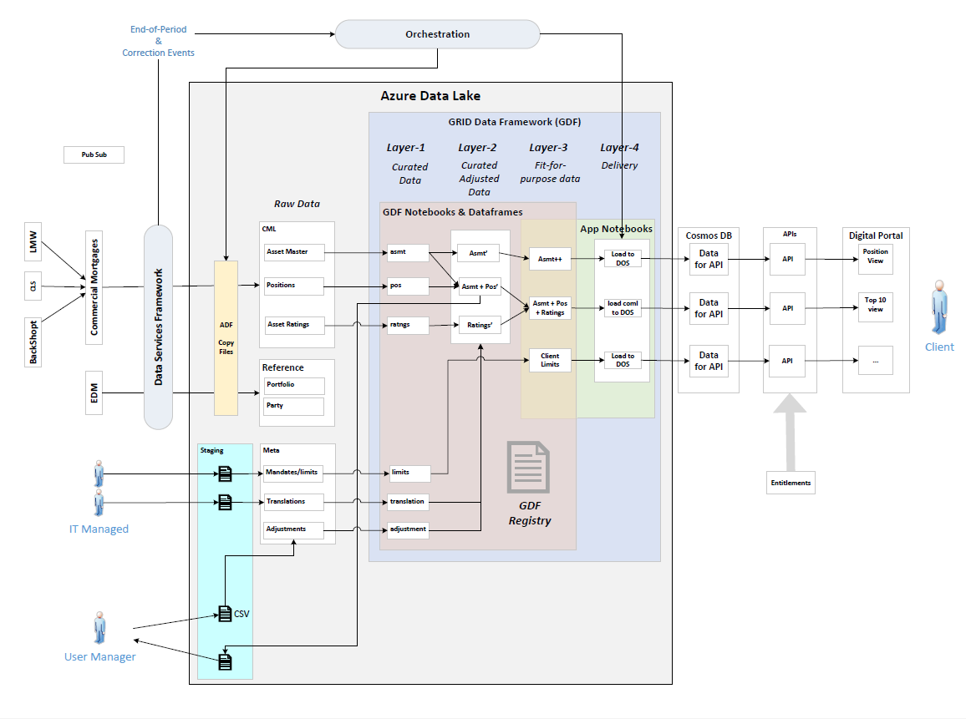

Software Configuration

General Software Components

Description | Tool/Language | Vendor/In-house | Version
Microsoft Development Kit | Azure DataLake Gen2,Dot NET code through Azure functions,ADF, Service Bus, ,Blob Storage, DataBricks, App Service | Microsoft
Deployment | Azure DevOps, Git | Microsoft
Infra Tools | SCOM, | Microsoft
Monitoring Tools | Azure Monitor, App Insight and Log Analytics | Microsoft

Software Configuration – Workstation

ARM Templates for deploying the resources
https://mydrive.metlife.com/:p:/r/personal/dkamalakaran_metlife_com/_layouts/15/Doc.aspx?sourcedoc=%7B0A8DCB8C-CF29-4053-A9C4-B0EEA4E75891%7D&file=Azure%20Databricks%20POV.pptx&action=edit&mobileredirect=true

Database and Containers
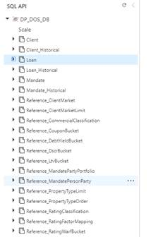

Overview

Software | Version | Vendor | Purpose | Special Configuration Requirements

Startup/Shutdown <Review and Update>

Overview
The Entex Support Staff in Rensselaer and Scranton or Remote Network Services handle startup and shutdown of the Systems.

Webserver Startup / Shutdown Procedures
N/A

Application clusters Startup / Shutdown Procedures
Databricks clusters: Always up

Database Server Startup / Shutdown Procedures
Startup
No special requirements
Shutdown
No special requirements

Mainframe Startup / Shutdown Procedures
N/A

Application Startup / Shutdown Procedures
Startup
No special requirements
Shutdown
No special requirements

Backups

Overview
The Core Services on-site staff members are responsible for following the standard backup schedule for the servers in the network.

Web Server Backup
N/A
.

Application Backup
<Need to update the app folders/data backup procedures>

Database Backup
NA

Mainframe System Backup
N/A

Restoring

Overview
Please reference the following document for all Restoring procedures for any Client Server hardware currently used by this Application. This function is maintained and performed by Core Services of MetLife. This document can be located in the MetLife Policies, Procedures, Standards and Guidelines database.

Webserver Restore
N/A

Application Restore
Restore procedures are performed by Core Services and follow those standard practices.
Hard drive should be re-imaged from the backup server.

Database Restore
Restore procedures are performed by Core Services and follow those standard practices.
Database will need to be restored from the most recent full backup of the production database.

Mainframe Restore
N/A

Application RACI
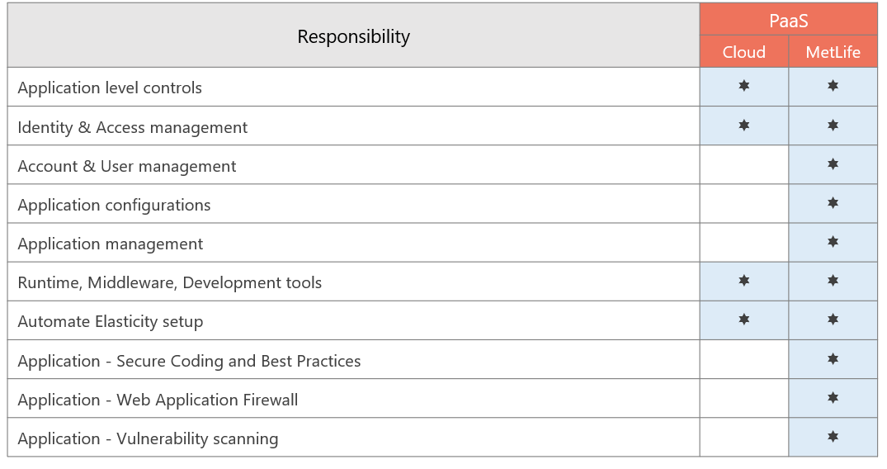

RACI for cloud
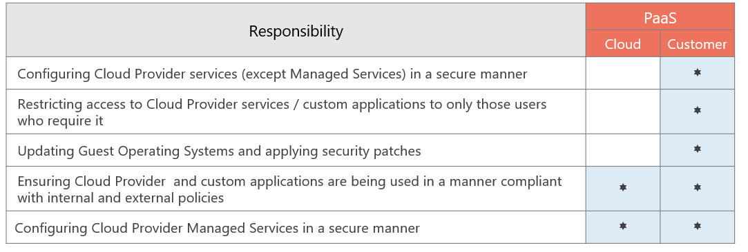

Azure DevOps
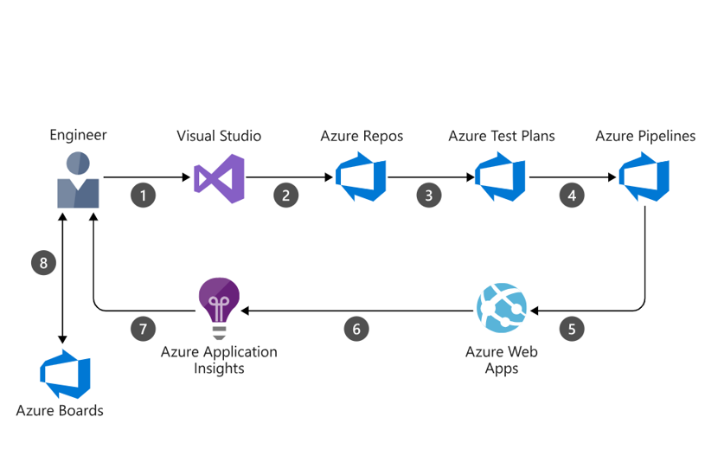

The data flows through the scenario as follows:
- A developer changes application source code.
- Application code is committed to the source code repository in Azure Repos.
- Continuous integration triggers application build and unit tests using Azure Test Plans.
- Continuous deployment within Azure Pipelines triggers an automated deployment of application artifacts with environment-specific configuration values.
- The artifacts are deployed to Azure App Service.
- Azure Application Insights collects and analyzes health, performance, and usage data.
- Developers monitor and manage health, performance, and usage information.
- Backlog information is used to prioritize new features and bug fixes using Azure Boards.

Job Scheduling/Monitoring

Overview
Jobs driven through Service Bus
Service Bus:
Resource Name: iazncqssvcsbus0001
Resource Group: inv-usnc-qa-mimd-shared-rg
Topics: https://iazncqssvcsbus0001.servicebus.windows.net/datafile-event-topic
Subscription: GRID-subscription
Function App:
Resource Name: qa-grid-app
Resource Group: inv-usnc-qa-grid-rg
Data Factory:
Resource Name: iazncqsadf0001
Resource Group: inv-usnc-qa-grid-rg
Name of Component being monitored: | GRID_PL_100_CPY_TO_DATAZONE
Function of Job | Copy the file from On-Premise path to azure data lake ORDZ and materialize it to IDZ
Time & Frequency:
Location:
Expected job duration | 15 mins
Success Identification
Failure Identification
Action on failure | Rerun
Input Files
Output Files
Log Files
Job/Schedule Dependencies:
People to be notified: | Catherine Bhama bcatherine@metlife.com  Office: 973-355-4136  Cell: 908-636-0419  Jiaqiao Zeng jzeng1@metlife.com  Office: 973-355-4054  Cell:  Francesco Puntillo  fpuntillo@metlife.com  Office: 973-355-4220  Cell: 908-340-7296
Remarks: | (anything else to say)

Disaster Recovery
Environment: PROD
Region: North Central US
DR Region: South Central US
DR Additions: Geo-Replication Enabled
Note: No RI Option Available in Azure
High availability (HA) and disaster recovery (DR) can sometimes be combined, although each has a slightly different strategy, especially when it comes to data. Data Lake Storage Gen2 already handles 3x replication under the hood to guard against localized hardware failures.
https://docs.microsoft.com/en-us/azure/storage/blobs/data-lake-storage-best-practices

Incident Management

Problem Management

Service Management

Contact Lists

Contacts | Weekdays  9 AM – 6 PM EST | Weekdays 6 PM- 9AM EST and  Weekends
Escalation Contacts for GRID Application Management | Catherine Bhama bcatherine@metlife.com  Office: 973-355-4136  Cell: 908-636-0419  Jiaqiao Zeng jzeng1@metlife.com  Office: 973-355-4054  Cell:  Francesco Puntillo  fpuntillo@metlife.com  Office: 973-355-4220  Cell: 908-340-7296 | Arun  sarun@metlife.com  Jhansi  jrani2@metlife.com  Hotline: (973) 368-9743
MetLife Investments Application Management CRE | Miguel Rivera  marivera@metlife.com  Office: 973-355-4003  Cell: 201-328-2998

ANY SPECIAL INSTRUCTIONS FOR THIS APPLICATION
N/A

TROUBLE SHOOTING
Use case –

DSF – Publish event

HELPDESK INFORMATION (CS PROJECT OFFICE)

Application’s Business Purpose: This application is used by the MeltLife Investment Management Group to centralize asset information to support their spread business.

Platform: Cloud

Security: NT authentication

Password Resets
- Handled by 1-800-ASK-MET2

Customer Base
How many customers: 10
Type of office and location: Investments
External company: N/A

Support of the application
- Vantive Group Name – N/A

- Contact Information- Name, phone #, Beeper #, cell phone #.
Same contact list as in Section 17.1.

- HotLine or External helpdesk numbers
Currently being setup.

- User Manual
Refer to ‘AIM User Guide’.

- Installation Guide
Refer to the following documents, ‘AIM Client Side Installation Guide’, and ‘AIM Server Installation Guide’.

- Technical problem determination guide
None available.

Physical location of the server(s) which this application will reside on:
Storage account Name
North Central for -prod and QA
East US – Dev , INT
ADF Instance name

Add table – Tech, regional, instance name

The interface of these application server(s) to the MetLife Network:
Servers are on the METNET domain.

Name of the servers as they will appear on the MetLife Enterprise:
<Need to update the physical server location>

If Helpdesk to CSD Helpdesk agreement:
Current Hours of operation:
Helpdesk structure:
Helpdesk Phone #
Number of Helpdesk Employees
Name of Helpdesk Management

**If Servers will be managed outside of MetLife Agreement:

- Contacts for :
Hardware issues on Servers
Application issues on Servers

- Information concerning any SLA's which have been established, either for internal MetLife support or with contracted vendors.
<Add Microsoft contact>
**********************************************************************************************************

SECURITY

NETWORK USER ACCOUNT CREATION
NT login.

NETWORK USER PASSWORD MAINTENANCE/RESET
NT login.

Appendix A- Glossary of Terms

